Physical Education Lesson for the Week
- Introduce the Muscle of the Month for April using the Slides attached – Show the pictures, explain what it’s used for and Try to perform a few push-ups to work those muscles.
- Each Day During April perform the activities on that specific day using your April activity calendar attached.
- Click the link below for a short workout video

https://fit.sanfordhealth.org/resources/fit-workout-yoga-flow-video?utm_source=hs_email&utm_medium=email&utm_content=85304753&_hsenc=p2ANqtz-8kMZ4P53MtEjfv1WRgB8Uhq1SUZdXnXmsBWvh7hbaslREtIwMct9k8GEhBfFeuGdJKaREDPh_GtvRmQlRnL5LfFS4kPg&_hsmi=85304753

Be Safe, Be Healthy, Stay Active!
Shaler Area School District
Primary PE Department

Yours in Fitness and Health,

Mr. Chmielewski
April - Muscle of the Month

Function of the Pectorals
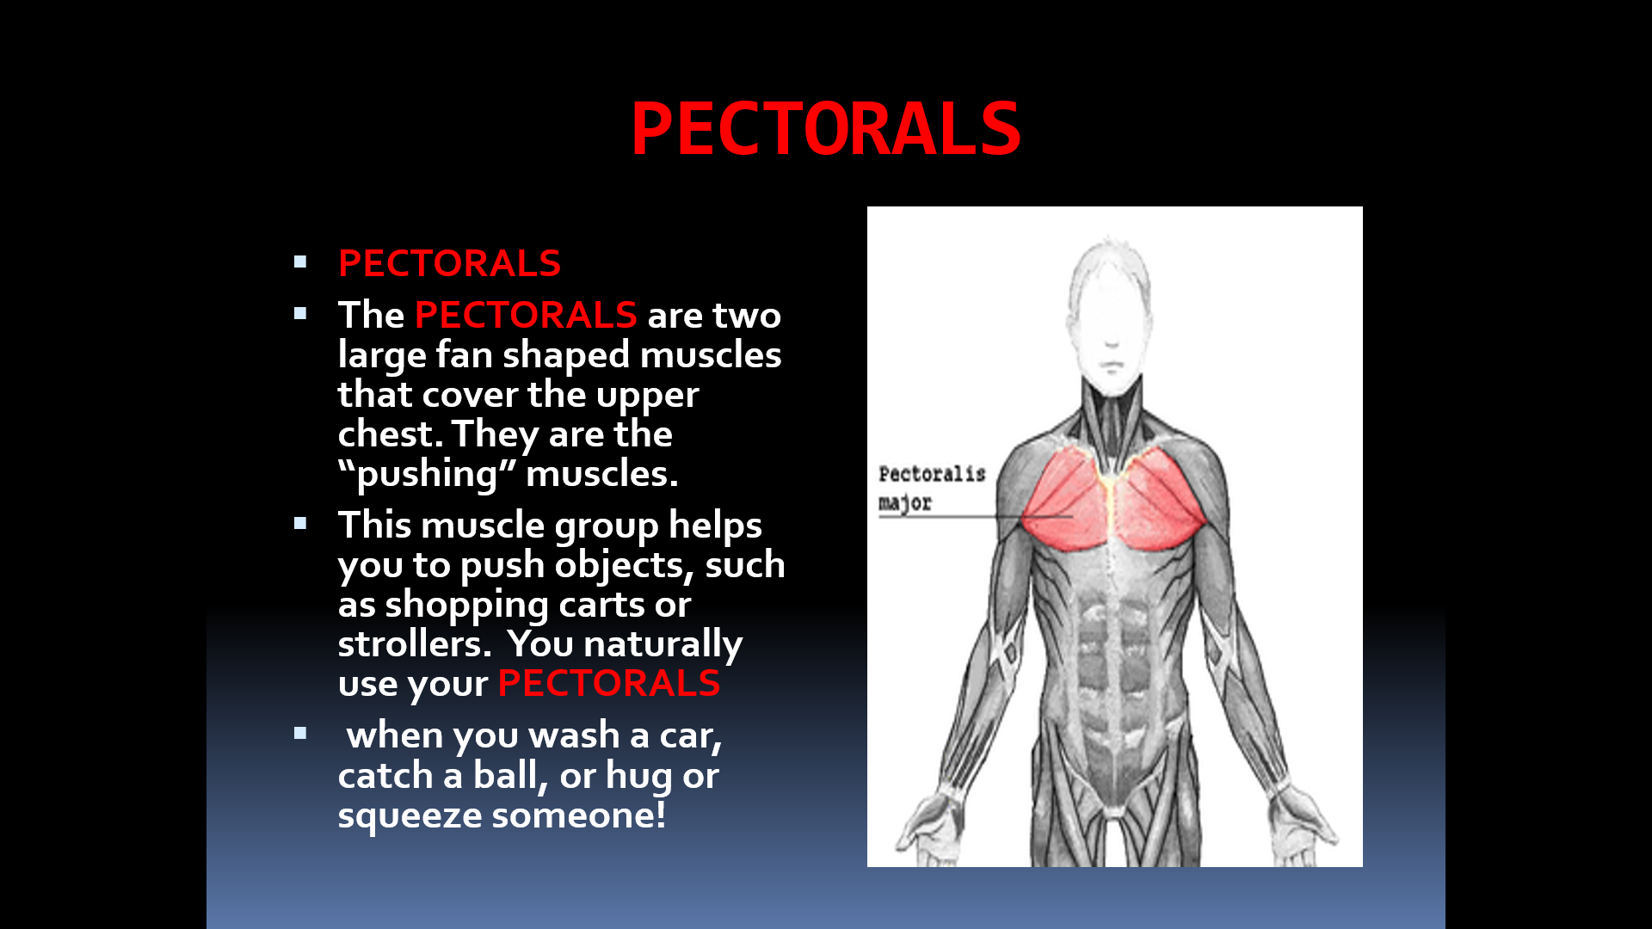
How do we use these muscles in PE?
The Pectorals are used for muscular strength and muscular endurance in PE class.
